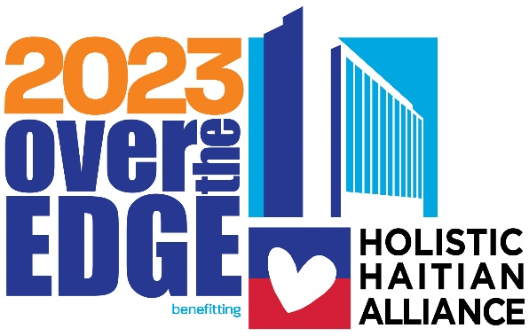

#### Fundraising Toolkit for Participants

##### Thank you for signing up to go Over The Edge for Holistic Haitian Alliance (formally Helping Haitian Angels)! We are thrilled to have you join us as we work together to provide holistic care for vulnerable children at HHA's Kay Anj Village (KAV) and in the community of Dekle, Haiti. This toolkit contains several exciting tips and tricks to increase your impact and fundraising efforts. Your engagement in fundraising and participating in our Over The Edge event will make a big difference in the lives of those in our community. The earlier you get started, the better!

Event Details 1-3

What is Over The Edge? 2

Who We Are 2

Event FAQs 3

Getting Started 4-5

How to Raise Funds 6-9

Best Practices 6-7

Inspiration 8

Fundraisers 9

Fundraising Worksheet 10



**FOR MORE HELP**Contact your Event Manager, Lora for tips or for answers to any of your questions hone:

Email: [lora@holistichaitianalliance.org](mailto:lora@holistichaitianalliance.org)



Letter Templates 11-12

**Event Details**

# What is OVer the edge?

Over The Edge is a special events company that provides signature events for non-profit organizations anywhere in North America and is expanding globally! Business leaders, individuals, and community members are invited to raise donations in exchange for the experience of going Over The Edge of a local building. Over The Edge has raised over $70 million for non-profits worldwide.

# Who we are

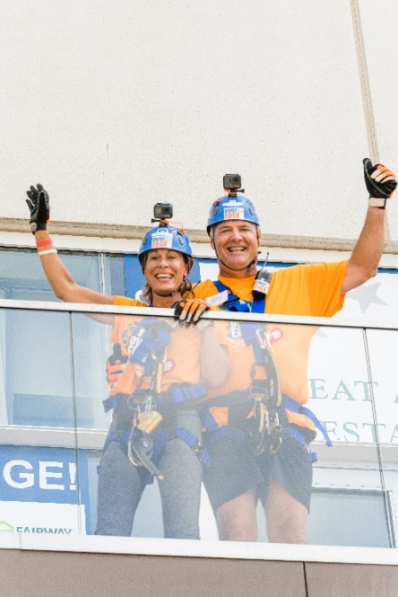Holistic Haitian Alliance, formerly Helping Haitian Angels, is a 501(c)3 non-profit organization that desires to see families and communities in Haiti thrive. Our growing alliance includes our children, over 70 employees, local community leadership, government officials, and other NGOs. In the past 15 years, we have helped over 60 children reunite with a safe family. We have created loving foster homes for those who remain in our full-time care at our Kay Anj Village in Dekle, Haiti.

Our Kay Anj Village (KAV) is located on 40 acres in the Haitian commune of Dekle, just outside Cap-Haitien. In addition to our foster homes, KAV has an education campus with primary, secondary, and vocational schools, a dental clinic, five farms, transitional care for young adults, volunteer housing, and is home to Hope Church – our growing community center of Evangelism.

When we supply safe adults around children who are vulnerable, then those children have a high success rate; they go on to hold jobs, support their families, pour back into the local economy and raise healthy children themselves. Over time there becomes a cycle of children growing up in a safe and healthy family and then becoming a safe and healthy adults. To truly see families and communities thriving, we must invest in the lives of future generations while also caring for and aiding the current adults around those children. It may take generations to achieve our goal, but every child is worth it, and it's happening already!

Your support is critical to maintaining and expanding our impact on the lives of those most vulnerable. We need YOU and are so thankful for your courage in embarking on this journey Over The Edge with us.

# EVENT FAQs

|  |  |
| --- | --- |
| Minimum Age Requirement | Anyone can participate in an Over The Edge event. People in their 80s and 90s rappel! The only restriction is that anyone under the age of 18 requires a parent or guardian signature on the legal waiver. |
| Weight Requirement | Over The Edge's equipment safety standards require individuals to be between 100 and 300 lbs. to rappel safely. |
| Do I need to have experience to participate? | Not at all! **I've included a document** provided by Over The Edge on what to expect on event day! This document will tell you everything you need to know about the process, from registration to the roof and back down again! |
| Fundraising Minimum | $1250 Individual  $1000 per person for a Team of 3 or more |
| Number of rappel spots open | 102 |
| How many Stories will you be rappelling | 14 |
| Fundraising Deadline | August 26, 2023 |
| What should I wear to the event? | Dress comfortably! Do not wear overly loose or baggy clothing or clothing with long drawstrings. Wear soft-soled, close-toed shoes or sneakers. |
| Can I wear a costume? | Costumes are allowed but are subject to the same limitations as baggy clothing. Every attempt will be made to fit costumes around harnesses and helmets safely. As with shorts, it is ultimately the decision of the Site Safety Supervisor. Stringy, loose, or excessive costumes must be avoided. Headpieces that will not accommodate a helmet, obscure the vision, or are notably large or heavy will rarely be allowed. |

# Getting STarted

**Fundraising Made Easy!***Maximize your impact and invite your community to join your efforts.*

* Step 1- Sign up! Visit our Over The Edge event page at <https://www.holisticehaitanalliance.org/over-the-edge/>
  1. You will need to register for the event on our website. A $50 registration fee will count toward your fundraising goal. After registering, you will need to create a fundraising page. Take advantage of this opportunity to personalize your page by uploading a picture, setting your fundraising goal, and including a message about why you are participating!
* Step 2- Ask!
  1. The number one reason that people give is that they are asked. Don't be shy about telling everyone you know you are participating in Over The Edge for Holistic Haitian Alliance. Don't forget to go to places you spend money, like your hair salon, favorite restaurant, or gym.

***Beat the Average***

*Use this fun and easy plan to raise over half of your fundraising goal in only 6 weeks:*

**When? Who To Ask? Watch Your Total Grow!**

Registration Fee $50

Week 1 Use your online personal page to sponsor yourself $200

Week 2 Ask 6 Family Members/Friends for $25 each $150

Week 3 Ask 6 Co-workers for $25 each $150

Week 4 Get 4 businesses you frequent to sponsor you for $100 each $400

Week 5 Ask your Boss to support your efforts $200

Week 6 Ask 6 more Family Members/Friends for $25 each $100

***Your 6-Week Grand Total $1250***

* Step 3- Follow Up!

Always follow up! Many people will need more than one request to donate, and most will appreciate the reminder. Include fun facts and an update on how close you are to reaching your goal.

Send a thank you letter, note, or message to your donors. Consider including a crazy picture of you from the event for your sponsors so they remember you next year.

* Step 4- Reach your goal? Keep going!

Raise…

* **$1250** - Receive 1 Rappel spot, Rooftop photo, T-shirt, and Swag Bag
* **$1800** – All the $1250 level benefits plus rappel to your song of choice
* **$3500** – All the $1800 level benefits plus you'll enjoy lunch with HHA Founder Debbie Harvey and an HHA Board Member at your choice of any one of Great American Restaurant's 17 locations.
* **Top Fundraiser** – You are HHA's true VIP! Receive all the incentives from the prior levels plus a two-night stay at the Hyatt Regency Tysons Corner Center during the event; dinner for two at Randy's Prime Seafood and Steak; and special recognition during Friday Night's Kick-Off Reception
* 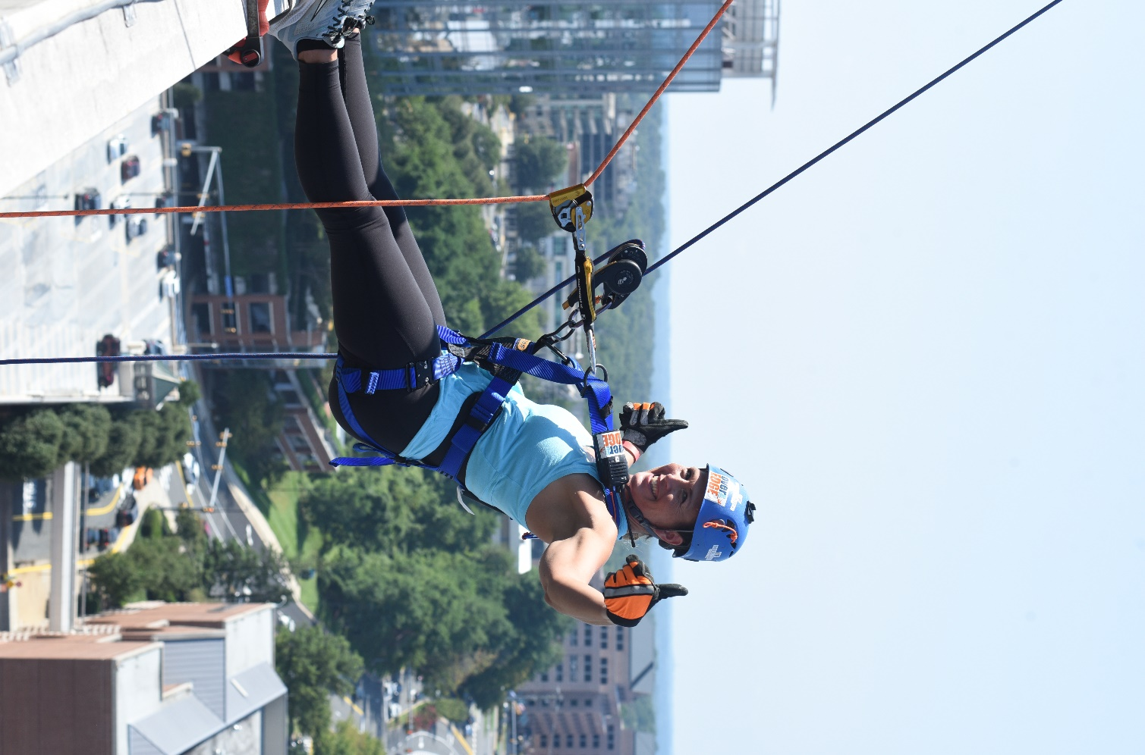Step 5- Have Fun! You've worked extremely hard to reach or surpass your goal. Get a group of family and friends together to watch you go Over The Edge. Take time to enjoy the view and remember the good work you did for kids in Haiti. Remember to post a photo after your event to your social media accounts to show your supporters that YOU DID IT!

# How to raise Funds



**Know your Facts!**Make sure you’re able to talk about our mission in terms of how the funds you ask for will make a difference. People give because they are asked, because they care, and because the person that is asking is passionate about the cause.

You've registered to go Over The Edge; you have the date circled on your

calendar; now what? Start fundraising today! Before you know it, you will have

your pledged amount raised and be on your way to the top!

**Best Practices**

1. **Start Early!** 
   1. Although it may seem like you have all the time in the world to fundraise, this event will be here sooner than you think! The sooner you start fundraising, the more money you will raise for HHA and the sooner you will reach your goal.
   2. Remember, as soon as you reach your goal, you will be able to choose your fundraising time and officially make it onto the event schedule!
2. **Create an Email Schedule!**
   1. It is easy to be super keen when you start your fundraising journey but lose steam a couple of weeks in.
   2. To make sure you are reaching out to your potential donors consistently, create an email schedule with specific dates and diverse content.
   3. This ensures that you will be switching up your messaging so your potential donors are not receiving the same request repeatedly. Keep it interesting.
   4. Suggested topics for your emails:
      1. Ask HHA to provide mission-related blurbs to add to your emails. This keeps your potential donors updated on WHY you are doing this and how it is helping.
      2. Include updates on where you are in the fundraising process and how much more you need to reach your goal.
      3. Include pictures and videos from Over The Edge – just ask us for them!
3. **Get Help From Your Support System!** 
   1. If your friends and colleagues are not able to donate, that's OK! There is lots they can do to help you reach your goal.
   2. Ask them to share your personal fundraising page on their social media forums
   3. Provide them with "info cards" about the event, including your fundraising website, and ask that they distribute them to their network.
   4. Ask them to reach out to the people in their lives who may be connected to the mission and would consider donating.
4. **Make a Video!**
   1. Instead of writing post after post on your social media forums, consider switching it up! Make a video detailing what you are doing and why you are doing it.



Add the event logo to your e-mail signature. You can also include a hyper-link to your personal fundraising website and encourage everyone to visit it and support your efforts.

* 1. Most viewers will watch a video before they read a post.
  2. It is easier to communicate the mission of the non-profit profit you are supporting when speaking about it – the video makes it more personal.

1. **Use Your Community Connections!**
   1. Get something donated from a business in your community.

(gift certificate, swag bag, service, etc.)

* 1. Create a raise-athon week!
  2. In your email and on social media, use wording like this "Everyone

who donates to me this week will go in a drawing to win _______."

* 1. At the end of the week, get someone to take a video of you drawing a name and post it! That person wins something, and you've made some extra money!

**Fundraising Inspiration**

* Floor sponsors and donations
  + Divide the number of floors into your minimum amount raised
  + $1250/14 floors, $90 pledge per floor
* Foot sponsors
  + Same as floors, except using the height of the building in feet
  + $1250/200 feet, $7 per foot
* Corporate matching
  + Many companies will match charitable contributions their employees make. See if your company will match your donations or the total funds you raise. If they only match employee giving, get as many of your co-workers to give as possible.
* Corporate donations
  + Don't forget you can ask area businesses to support you.
* Office campaigns
  + You can put together some mini fundraisers to benefit your cause
  + Bake sale – sell cookies at your desk.
  + BBQ fundraiser (charge for lunch or ask for donations)
  + Baskets – keep a donation plate on your desk or in a common area
  + Challenge: have a peer in another department go Over The Edge with you and see who can raise the most money, or whoever raises the most must go Over The Edge. For execs, challenge other departments or challenge an exec from another company!

# Fundraisers

Fundraisers are really just excuses to have a party! Think of something that you and your friends and/or family like to do and make it a benefit to help you get to go Over The Edge in August.

**Key Elements**

Start planning early

* Promote your event
* Use social media and e-vites to spread the word quickly and cheaply
* Be sure to send out reminders as your event approaches
* Tell each guest to bring another friend or two
* Decide if you'll be charging a flat rate or simply asking for a suggested donation
* Include a silent auction or raffle to increase donations at your event
* Pass around a jar at the event and ask people to donate their change

**Don't know what to plan??**

We've included some great ideas for you below. Not everything on this list will appeal to you. Pick something that sounds like fun and start planning! If you need help planning a great fundraiser, let us know. We are here to help!

* Babysitting by Donation Bachelor/Bachelorette Auction Bake Sale
* BBQ Cook-Off
* Clothing Swap Night
* Be a Designated Driver- Ask for donations
* Benefit Concert Bingo Night
* Board Game Tournament Bowling Tournament
* Car Wash Chili/Spaghetti Cook Off
* Craft Show Dinner Party
* Dodgeball Tournament Dog Wash
* Garage Sale Holiday Bizarre Karaoke Night
* Kick Ball Tournament Movie Night
* Pancake Breakfast Pet Sitting
* Pizza Party
* Poker Tournament Raffle
* Scrapbook Party
* Sell something on eBay Silent Auction
* Snack Basket at Work Softball Tournament Trivia Party
* Volleyball Tournament Wine & Cheese Party

**FUNDRAISING WORKSHEET**

Use this form to list all possible donors to your fundraising effort. Once you have listed everyone, you can think of and assign an "ask" amount to each, start fundraising and keep track!

|  |  |  |  |
| --- | --- | --- | --- |
| **Donor Name** | **Relationship to Me** | **Ask Amount** | **Received?** |
| **1.** |  |  |  |
| **2.** |  |  |  |
| **3.** |  |  |  |
| **4.** |  |  |  |
| **5.** |  |  |  |
| **6.** |  |  |  |
| **7.** |  |  |  |
| **8.** |  |  |  |
| **9.** |  |  |  |
| **10.** |  |  |  |
| **11.** |  |  |  |
| **12.** |  |  |  |
| **13.** |  |  |  |
| **14.** |  |  |  |
| **15.** |  |  |  |
| **16.** |  |  |  |
| **17.** |  |  |  |
| **18.** |  |  |  |
| **19.** |  |  |  |
| **20.** |  |  |  |

**Fundraising Letter Template:**

Hello Family and Friends,  
   
I have signed up to do something many of you may think is crazy. I have joined Over The Edge to support Holistic Haitian Alliance (formerly Helping Haitian Alliance). Over The Edge is much like it sounds. I will stand on the Hyatt Regency Tysons Corner Center's rooftop, step over the edge, and rappel 200 feet to the ground! I'm not making this up… check out the event website.  
<https://www.holisticehaitanalliance.org/over-the-edge>

I am not asking you to rappel the building with me, but I will need your support to get to the top. I am not only pledging to go Over The Edge but also committing to raise $1250 for HHA. Since 2008, HHA has provided holistic care for vulnerable children in Kay Anj Village (KAV) and the community of Dekle, Haiti. When the circumstances these children were born into did not provide them with a future, HHA did. HHA loves, honors, and raises future leaders who will promote a more just society in Haiti through programs that equip Haitians to become the authors of their own development.

How can you help? By making a 100% tax-deductible donation to my website here: (insert your website)

You may also send checks or money orders made out to Holistic Haitian Alliance:

ATTN: OTE – (insert your name here)  
Holistic Haitian Alliance  
P.O. Box 692  
Haymarket, VA 20169

Please help me support the great work that Holistic Haitian Alliance is doing. I promise to climb down the building in return!

Thank you for supporting Holistic Haitian Alliance and helping me to go OVER THE EDGE.   
   
Sincerely,  
   
(Your name here)

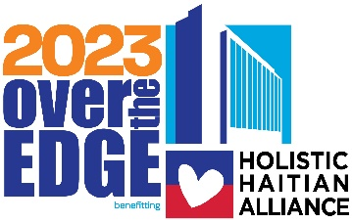**Reminder Letter Template:**

Hello Family and Friends,  
   
Thank you so much to everyone that has already donated! I wanted to share an update and let you know how my efforts to get to the top of Hyatt Regency Tysons Corner Center are going. So far, I have raised ($XXX). If I can raise $1250, I will stand on the roof of Hyatt Regency Tysons Corner Center in downtown Tysons Corner, step Over the Edge, and rappel 200 feet to the ground! I'm not making this up… check out the event website. <https://www.holisticehaitanalliance.org/over-the-edge>

I am not asking you to rappel the building with me, but I will need your support to get to the top. I am committing to raising awareness for Holistic Haitian Alliance by going Over The Edge and pledging to raise money to help provide holistic care for vulnerable children at HHA's Kay Anj Village (KAV) and the community of Dekle, Haiti.

How can you help? By making a 100% tax-deductible donation to my website here: (insert your website)

You may also send checks or money orders made out to Holistic Haitian Alliance:

ATTN: OTE – (insert your name here)  
Holistic Haitian Alliance  
P.O. Box 692  
Haymarket, VA 20169

Please help me support the great work that Holistic Haitian Alliance is doing. I promise to rappel off a building in return!

If you have already donated or want to help even more, please feel free to pass this email along!

Thank you for supporting Holistic Haitian Alliance and helping me to go OVER THE EDGE!   
   
Sincerely,  
   
(Your name here)